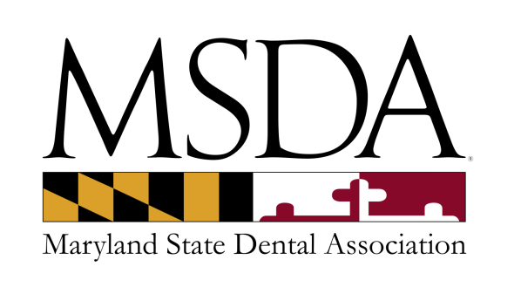

**AFFILIATE MEMBERSHIP APPLICATION**

**Qualifications for membership:** Dentists who are members in good standing of another constituent society of the American Dental Association but who have an interest in the activities of the Maryland State Dental Association.

**Benefits:** Subscription to MSDA printed newsletter ⬩ listing in the printed MSDA Membership Directory under Affiliate Member ⬩ Tripartite member rates on advertising and courses

**Dues:** $200.00 per year

Checks should be payable to the MSDA & mailed to the address noted below along with this completed application.

We also accept VISA/MASTERCARD/DISCOVER/AMEX.

Credit card number: ___________________________________________________________________

Expiration date: ________________________ CVV Code: _____________________________________

Name: ______________________________________________________________________________

Business Address: _____________________________________________________________________

____________________________________________________________________________________

Office Phone: ____________________________ Fax: _________________________________________

Email address: ________________________________________________________________________

Website: _____________________________________________________________________________

I am a member of the ___________________________________ State Dental Society/Association in the state of ______________________. I certify that I am a member in good standing of my main constituent society of the ADA and wish to apply for Affiliate membership in the MSDA.

Signature: __________________________________________ Date: ____________________________

**Return to: MSDA via Fax: (410) 964-0583 or membership@msda.com   
Questions, contact MSDA Membership at (410) 964-2880.  
MSDA 8901A Herrmann Drive ⬩ Columbia, MD 21045**